

**PROJECT SYNOPSIS REPORT**

**DYNAMIC ROUTER OPTIMIZATION AND EMISSION REDUCTION SYSTEM**

**PRESENTED BY** : TEEYA(2401201137)

SHREYA(2401201142)

NITIN(2401201106)

BHUMIKA(2401201144)

**UNDER THE SUPERVISION OF:**

MR. ASHWINI KUMAR

**Project Overview**

This project proposes a dynamic routing system that integrates real-time data on traffic, weather, and vehicle specifications to identify the most efficient and environmentally friendly routes. The solution will leverage multiple APIs and provide an intuitive user experience through a React.js-based frontend.

**Key Tasks**

* + Develop a Python-based dynamic routing system using real-time data from various applicable APIs.
  + Optimize vehicle routes considering traffic, weather, and vehicle-specific details.
  + Estimate and minimize vehicle emissions for each route.
  + Ensure the system is user-friendly and accessible.

**ABOUT THE PROBLEM**

**Problems Identified:**

* Inefficiency in traditional static routing methods that do not adapt to real-time traffic and weather conditions.
* High carbon emissions due to inefficient route selection and prolonged idling times.
* Lack of integration between different data sources like traffic, weather, and vehicle parameters.

**Issues or Problems:**

* Conventional routing solutions do not incorporate dynamic changes such as traffic congestion, accidents, or adverse weather conditions.
* Inefficient route planning leads to increased fuel consumption and operational costs.
* Lack of emissions tracking results in logistics companies failing to meet sustainability goals.

**PROBLEM STATEMENT**

Logistics companies need an advanced route optimization system that adapts to real-time traffic, weather, and vehicle-specific parameters while actively minimizing carbon emissions. Current solutions lack this capability, resulting in inefficiencies and environmental harm. The project aims to develop a dynamic routing system that provides real-time optimized route recommendations, integrates emissions tracking, and offers an intuitive user interface through a React.js frontend.

**Why This Solution Matters:**

* Static routing methods based on historical data.
* Navigation tools like Google Maps and TomTom, which provide traffic information but do not integrate emissions tracking or vehicle-specific parameters.

**OBJECTIVES**

* Optimized Route Planning: Utilize real-time traffic, weather, and vehicle-specific data to calculate the most efficient routes.
* Reduced Delivery Time: Proactively avoid congestion and delays to improve delivery efficiency.
* Carbon Emission Reduction: Identify and recommend eco-friendly routes to minimize transportation emissions.
* User-Friendly System: Develop an intuitive React.js-based interface for seamless user interaction.

**METHODOLOGY , TOOLS AND TECHNIQUES**

**Approach:**

* Integrate real-time data from multiple APIs to dynamically adjust routes.
* Implement a backend system using Python and Flask to process data and calculate optimized routes.
* Develop an interactive frontend using React.js for user-friendly route selection and emissions tracking.

**Tools & Software:**

* **Programming Languages:** Python (backend), JavaScript (React.js frontend)
* **APIs:**
  + TomTom: Real-time traffic information
  + Google Maps: Geospatial and navigation data
  + AQICN: Meteorological and air quality data
  + OSRM: Open-source route optimization
* **Backend Framework:** Flask (for API integration and server-side logic)
* **Database:** MongoDB (for storing route and emissions data)
* **Styling Framework:** Tailwind CSS (for a modern and responsive user interface)

**Justification for Chosen Methods:**

* Python's flexibility and extensive library support enable efficient data processing.
* React.js ensures a highly interactive and user-friendly experience.
* API integration allows real-time adaptability to traffic and weather conditions.

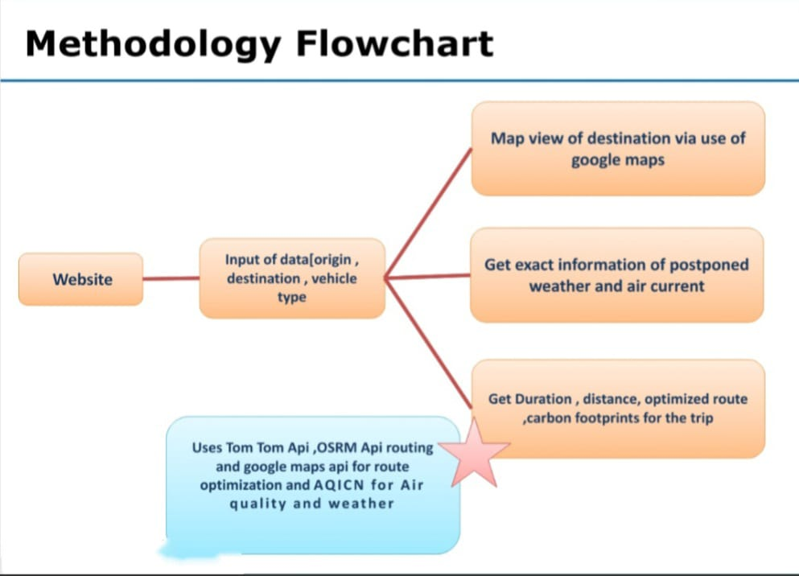

**PROJECT TIMELINE**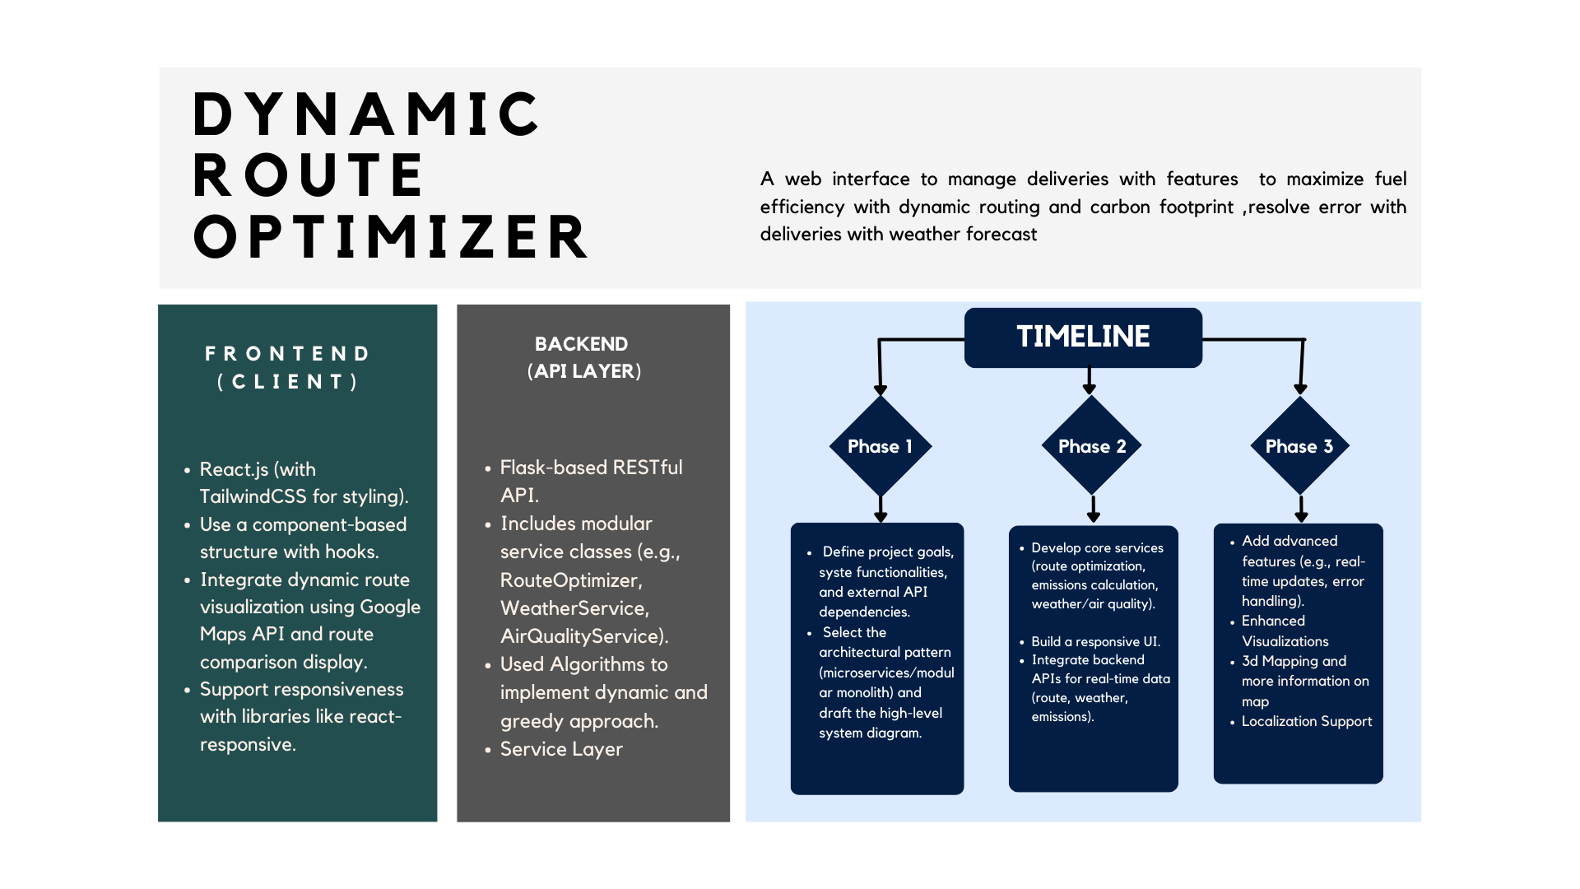

**EXPECTED RESULTS AND OUTCOMES**

**Expected Results:**

* A fully functional dynamic routing system capable of adapting to real-time data.
* Significant reduction in delivery times and fuel consumption.
* A working prototype that demonstrates route optimization and emissions tracking.

**Impact:**

* **Industry Contribution:**
  + Increased operational efficiency for logistics companies.
  + Better decision-making through real-time data integration.
* **Environmental Benefits:**
  + Lower carbon emissions due to optimized routes.
  + Promotion of sustainable logistics practices.
  + 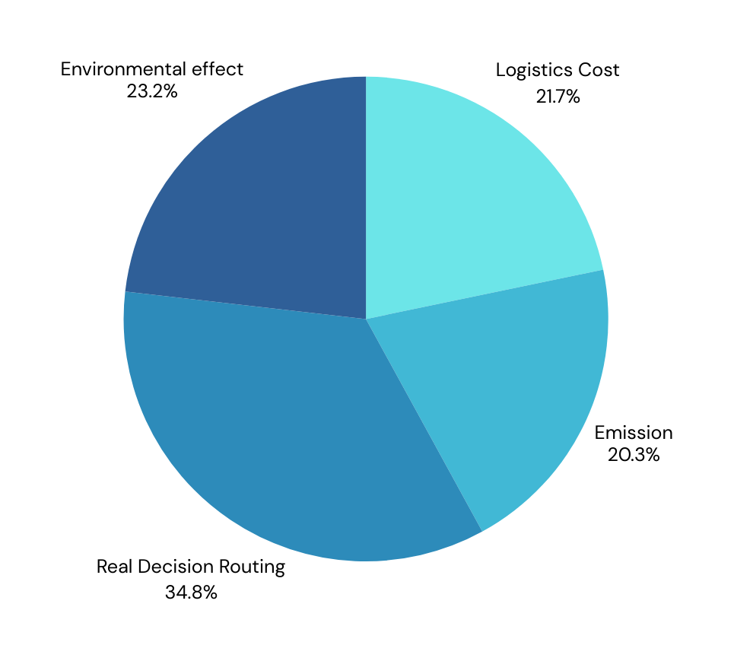

**REFERENCES**

**API Documentation:**

* Googlemaps:<https://developers.google.com/maps>
* AQICN:<https://aqicn.org/city/delhi/>
* Openweather:<https://openweathermap.org/>

**Python (FLASK)Documentation:**

* Library for quickly building web applications and APIs without unnecessary complexity.
* Link: <https://pypi.org/project/Flask/>

THANK YOU